Team B Members: Aman Ahmed, Fahim Ahmed, Zineddine Daif, Ali Elzalmy, Coreen John, Aaron Meressie, Benji Misner, Ahmed Mohamed

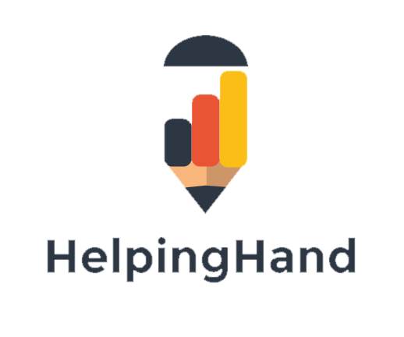

**Team B**

**Final Report**

**Table of Contents**

1. Introduction 2

2. Development Record 2

2.1. Technology 3

(a) Basic design concept 3

(b) Parent interface 3

(c) Tutor interface 8

(d) Revenue collection 8

(e) Other features 8

2.2. Preliminary development 9

2.3. Model-View-Controller 9

(a) Browser 9

(b) Model 9

(c) View 10

(d) Controller 10

2.4. Programming Languages 12

2.5. Development Structure 12

2.6. Database Structure 12

2.7. Parent account 12

2.8. User 13

2.9. Parent address 13

2.10. Parent preferences 13

2.11. Student preferences 14

2.12. Page structure 16

(a) User Registration 16

(b) User login 17

(c) User Login process 18

2.13. Agile Development 19

2.14. User stories 19

2.15. Backlog 20

2.16. Organisation of team: 26

2.17. Sprint planning meeting: 26

2.18. Frequency of sprints 26

2.19. Scrum meetings 26

2.20. Technology used to organise Kanban 26

2.21. Creation of Backlog 26

2.22. Complete 29

2.23. MVP 30

3. Formative Evaluation 30

3.1. User testing 30

3.2. Testing Constraints 31

3.3. Testing parameters 31

3.4. Schedule and testing location 31

3.5. Participant recruitment/approach 32

3.6. Facilitator and observer details for each session 32

3.7. Session details 32

3.8. Session recording 37

3.9. Outcome of user testing 38

3.10. Summary of user testing 53

4. Design and Implementation 53

4.1. Implementation 53

4.2. Design amendments 54

4.3. Key components 54

5. Quality Assurance 57

5.1. Unit testing 57

5.2. Test cases 57

5.3. Carrying out the unit testing 57

6. Ethical Audit 61

6.1. Privacy Policy 61

6.2. Collation of personal information 61

6.3. How personal information is collected 61

6.4. What is done with personal information 61

6.5. Data protection 61

6.6. Intellectual property 62

7. Summative Evaluation 62

8. Bibliography 65

9. Appendices 66

Appendix A. Consent forms from User Testing sessions 67

**Table of figures**

Figure 1: Parent registration form – User Credentials 4

Figure 2: Parent Registration form - Address details 5

Figure 3: Parent registration - subject selection 6

Figure 4: Parent Registration - Support subjects and mode of study 7

Figure 5: Model-View Controller for HelpingHand Application 11

Figure 6: Database Schema 15

Figure 7: User registration page process 17

Figure 8: User Login process 18

Figure 9: Parent and Tutor user stories 19

Figure 10: Phase 1 – Flowchart for Backlog 21

Figure 11: Backlog for Main website 22

Figure 12: Phase 2 - Backlogs 24

Figure 13: Backlog for Parent/Tutor pages 25

Figure 14: New sprints 27

Figure 15: Sprints - To do 28

Figure 16: Sprints in progress 29

Figure 17: Closed sprints 30

Figure 18: Dummy logins 37

Figure 19: Give Help, Get Help 56

Figure 20: Pages to be used for unit testing 57

Figure 21: Webpage interaction 58

Figure 22: Test case results 60

Table 1: User 1 - Testing analysis 40

Table 2: User 2 - Testing analysis 42

Table 3: User 3 - Testing analysis 44

Table 4: User 4 - Testing Analysis 46

Table 5: User 5 - Testing analysis 48

Table 6: User 6 - Testing Analysis 50

Table 7: User Testing - Observational Comments 52

**ROLES AND RESPONSIBILITIES**

|  |  |
| --- | --- |
| **Team member name:** | **Role** |
| Aman Ahmed | User Testing Recruiter |
| Fahim Ahmed | User Testing Recruiter |
| Zineddine Daif |  |
| Ali Elzalmy | Project Manager Scrum master Back-end developer Front-end developer User testing facilitator |
| Coreen John | Back-end developer Front-end developer User testing facilitator Document Administrator |
| Aaron Meressie | Back-end developer Front-end developer User testing facilitator Document Administrator |
| Benji Misner | Back-end developer Front-end developer |
| Ahmed Mohamed | User Testing Recruiter |

# Introduction

The tutoring industry is currently valued at £2m (Guardian, 2016), 40% of private tutoring was used by children in London and 1 in 10, 11-16 years old received private tutoring in England and Wales (Guardian, 2016). There seems to be a trend (Guardian 2016) towards more affluent families being able to provide their children with the option of having a private tutor to enhance and complement their education. This has alerted The Sutton Trust a charitable organisation aimed at increasing social mobility through education warns that at some point increase the inequalities of education for less affluent students (Guardian, 2016). The Sutton Trust an education charity has suggested that the Government should introduce a means-tested system to enable less advantaged children to benefit from private tutoring and close the education knowledge gap.

During extensive research that was conducted by the development team it was identified that a gap needed to be closed in how underprivileged children were able to access private tutoring at an affordable price. As a result of this identification a connection tool, ‘HelpingHand’ was proposed to help connect parents with university students. Parents can use the service to connect with a university student who can offer their child tuition in the subject that the child needs assistance with. The aim of the HelpingHand connection tool was to be a service that offers university students a channel to earn extra money in their spare time, through an informal system (the university student would be verified through their university credentials). It is also aimed to help parents access tutoring, also in an informal manner.

This report will be used to illustrate to Stakeholders and users how the HelpingHand tool was developed. It aims to demonstrate the methodology used to choose and implement the most appropriate technology required to make the application fully functional and the reasoning behind the choices made. The report will also give an account of how the workload and team was managed through a process of agile development and the steps that were necessary to implement this. A full analysis will be given on the user testing that was carried out on the software and feedback from the participants. There will be an in depth analysis of how this feedback affected the future development of the application. The report will then give insight on how the application will be taken forward in the future.

# Development Record

In order to develop the HelpingHand application various types of technology was identified in order to implement effective functionality for the HelpingHand application. In order to identify the technology a thorough analysis was conducted so that an informed decision could be made which is outlined below.

## Technology

### Basic design concept

It was established that there will two main users of the application:

* Parents (who have established that they need assistance for their children); and
  + Tutors (who have been identified as university students).

In order to satisfy the needs of the identified user groups the HelpingHand application will be divided into two categories as follows:

### Parent interface

The parent interface will primarily be used as a platform for parents to post jobs in order to locate a tutor. The interface will ask parents register their preferences using a signup registration form (see Figure 1 to Figure 4 below. These preferences will be used to match a tutor to their child based on their selection. Once the parent accepts a tutors request for their job, the platform will allow the parent and tutor to communicate via a messenger service directly through the application.

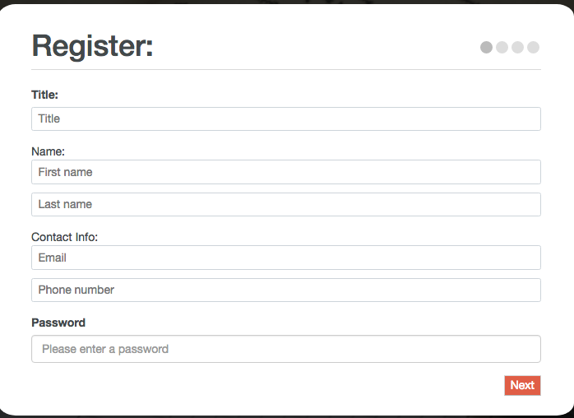

Parent users can enter their credentials on the first page of the registration form.

Figure 1: Parent registration form – User Credentials

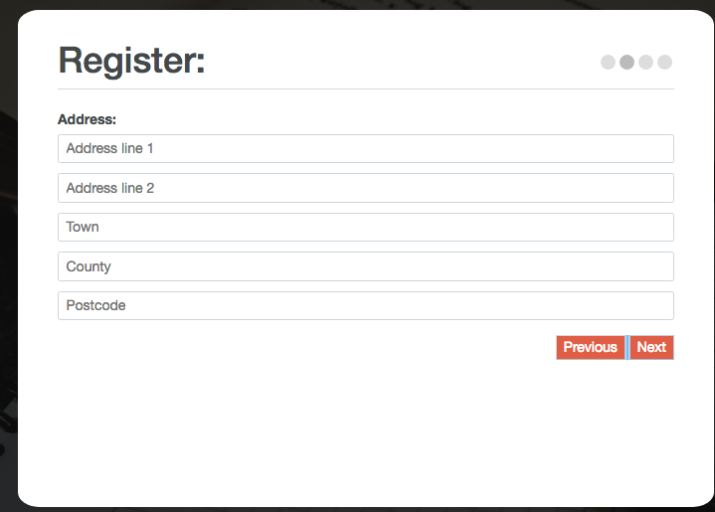

Parent users can enter their address details on the second page of the registration form.

Figure 2: Parent Registration form - Address details

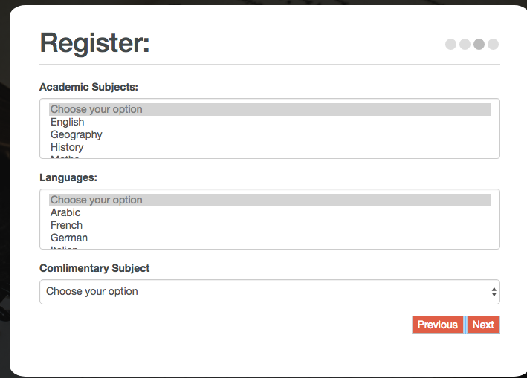

Parent users can enter their academic subject preferences.

Figure 3: Parent registration - subject selection

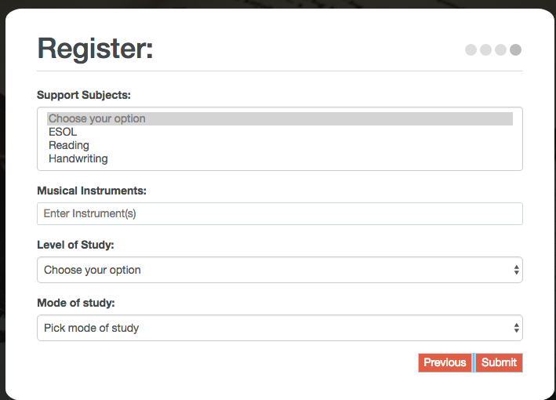

Parent users can enter their mode of study and submit their preferences.

Figure 4: Parent Registration - Support subjects and mode of study

### Tutor interface

The tutor interface will be used as a platform to allow the tutor to apply for jobs that have been posted by parents. These preferences will be used to match a tutor to their child based on their selection. Once the tutor accepts the parents request of a job, the platform will allow tutor the ability (as highlighted in above) to communicate via the messenger service to arrange how and when the tutoring session will be conducted.

### Revenue collection

The system will collect revenue from the parent and tutor by way of a 10 % transaction fee when the connection and agreement is finalised.

### Other features

The platform will have added features as follows:

*5-star rating system*:

This feature is available once the tutoring session is complete. It enables the parent to leave feedback on the tutor’s services on a scale of 1 to 5 (one being the least five being the most).

*Map location:*

This feature can be used by both parents and tutors. Parents can use this feature to see where there nearest tutor is located. Tutors can use the feature to see where their nearest tutoring job can be located.

*User profile:*

Once the both types of users (Parent and Tutor have registered on the website their user provide will be stored on their dashboard page. The user profile will display user preferences that were entered on registration.

*Language Translation:*

One of our identified groups, are parents whose native tongue is not English. So in order to address the needs of these users a language translation service will be available to assist those who do not have English as their first language. All pages that appear on the website will be translated in the language of the user’s choice.

## Preliminary development

The HelpingHand platform will be based on a web application. The decision to develop the platform as a web based application was based on the following:

* The application would be accessible to all types of users as long as they are able to connect to the internet, which would eliminate restricting the service to select users only.
* The application will be easier to develop and customise. The application can be customised to suit the needs of the two user groups.
* Maintenance of the application will be less complex. If any upgrades or versions are released on the system, these will be instantly available for all users to access.
* The growth of the application will be better supported, as the application is developed and can take more sophisticated requests.
* As the application will be served by a dedicated server the effectiveness of the security will be more enhanced.

## Model-View-Controller

To analyse the validity of developing the platform as a web application a Model-View-Controller was devised (see Figure 5 below). The model affirmed the decision to use a web application as it highlighted the following:

### Browser

The browser will be the main communication channel throughout the use of the application. The Parent and Tutor user will use the browser for all of their activities around the site.

### Model

The relational database is the central component of the application. The database is responsible for managing the data requests that are filtered through the application by the parent and the tutor. The database is also responsible for acting upon instructions from the database and has the ability to self-update.

### View

The view is displayed in the form of parental requests and job postings. The view will also interact with the database to handle the requests of the parent and will filter these requests to the controller.

### Controller

The controller is responsible for responding to the users requests by analysing the input of the user (so if a parent makes a request it will match it to a tutor) validate the request and sent it back to the view. It will update the model according to the action that it has taken. The controller has the ability to handle logins, job postings and instant messaging.

/Users/coreenanderson/Google Drive/Business Computing 2017-2018/Software Projects 2017-18/Architectural Diagram/MVC.pdf

Figure 5: Model-View Controller for HelpingHand Application

## Programming Languages

The programming languages that have been selected to build the will include HTML/CSS and PHP. HTML will be the main structure of the webpages and CSS will be an integral part of the design. PHP is used throughout the application and is responsible for delivering information to the MySQL server. The login page uses PHP to store the user sessions on the website and is used to query the username and password that are delivered to the MySQL database. The database matches the user to the details that have been entered into the query.

## Development Structure

In order to develop the structure of the application development the programming languages were split into the following categories:

|  |  |
| --- | --- |
| Language | Front End/Back End |
| HTML | Front End |
| CSS | Front End |
| Bootstrap | Front End |
| Javascript | Front End |
| PHP | Back End |
| MySQL | Back End |

## Database Structure

The database uses MySQL programming language. The database has six distinct types of database in a relational database type. The database is structured as follows (see Figure 6 below):

## Parent account

The elements that will be contained for the parent account are:

## User

The elements that are contained in the user account are:

* User ID (foreign key linked to the User account);
* Account type; and
* Email address.

## Parent address

The elements that are contained in the parent address account are:

* Title
* First name;
* Last Name;
* Address 1
* Address 2
* Town
* County
* Country
* Postcode
* Phone; and
* User ID (linked as a foreign Key to parent account)

## Parent preferences

* Preference ID
* User ID (Linked as a foreign key to parent account)
* Academic subject
* Languages
* Computer subject
* Support subject
* Musical Instrument
* Level of study
* Mode of study

## Student preferences

* Student ID
* Academic subject
* Languages
* Complimentary subject
* Support subject
* Musical Instrument
* Level of study
* Mode of study
* Travel distance
* Parent preference



Figure 6: Database Schema

## Page structure

The user pages are structured into two main components: user registration and user login.

### User Registration

The user selects registration from the login tab and fills in their user details. The PHP scripts will send a request to the MySQL server and add the users’ details to the database to be stored. Please see Figure 7 below).

Registration process

Figure 7: User registration page process

### User login

The user selects login from the login tab and fills in their login details. The PHP scripts will send a request to the MySQL server to match the account details that have been entered on login. The MySQL server will return a statement of true or false. If the query returns true, the user is directed to their dashboard page. If the query returns false, the user is asked to re-enter their login details. Please see Figure 8 below).

### User Login process

Figure 8: User Login process

## Agile Development

In order to manage the project effectively and to ensure that a clear vision was maintained throughout the development phase of the project, agile software development life cycle to complete the development of the project. In order for this to work the following procedures were implemented: below

## User stories

In order to respond to the needs of the users it was important at the beginning of the development life cycle to revisit the user stories so that the development of the application kept in sight the aims and the needs of the user. Figure 9 below illustrates the user stories. There are two main users that the application is being designed for. Revisiting the user stories made the requirements of the users more transparent and made the planning of the development life cycle an easier process to plan and execute.

Figure 9: Parent and Tutor user stories

Parent

Tutor

As a student I want a way to make some extra money alongside my university studies, as well as using my skills I have learnt to help others.

As a parent, I want a quick, informal way of finding a good tutor online for my child to help with their school subjects and homework as I am unable to help them due to language barriers.

Helping hand connection is made

## Backlog

In order to determine and plan an efficient workflow, a backlog was devised for the main functionality of the application. The backlog was split into two parts: Phase 1 (see Figure 10 below) and Phase 2 (see Figure 12 below). It was decided to split the backlogs into two phases as then we would be able to develop the main pages of the application and test it. Phase 2 could then be developed and user testing could then be carried out by our users.

Phase 1:

The workflow for Phase 1 was designed to build the first five pages of the application. The decision to develop these pages first was decided as this would be the main entry point into the application. The flowchart demonstrates the functionality of the pages. The first five pages of the application are:

* Home
* About
* Services
* Contact
* Sign-up/Login

A backlog was then created to illustrate the core functionality and to establish and set tasks for the team (see Figure 11 below).

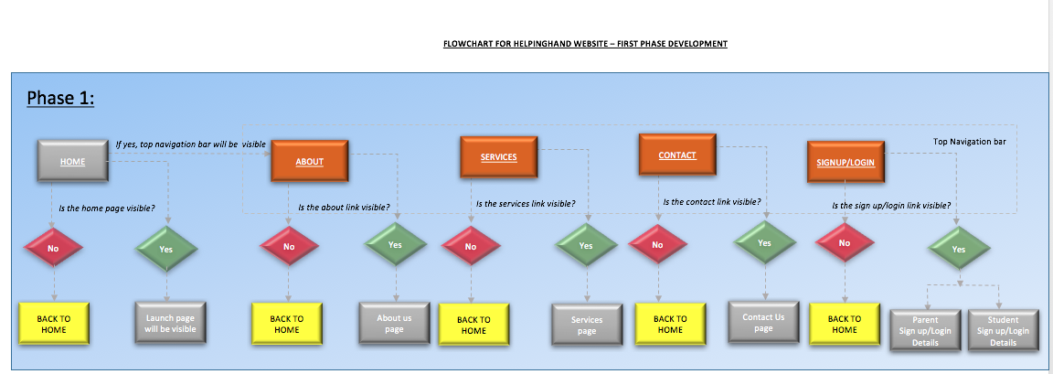

Figure 10: Phase 1 – Flowchart for Backlog

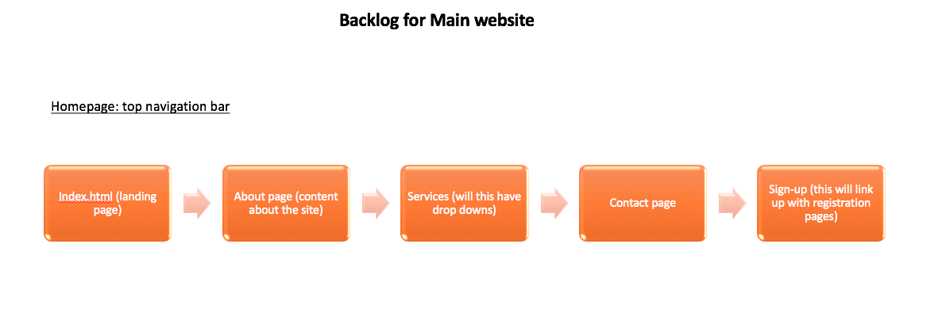

Figure 11: Backlog for Main website

Phase 2:

The workflow for Phase 2 was designed to handle the registration and login of users. The flowchart demonstrates the functionality of the pages. The pages of the sign-up process are:

* Sign/up login – page
* Parent login
* Tutor login
* Parent registration form
* Tutor registration form.

A backlog was then created to illustrate how the sign up process works and to establish and set tasks for the team for Phase 2 of the development (see Figure 13 below).

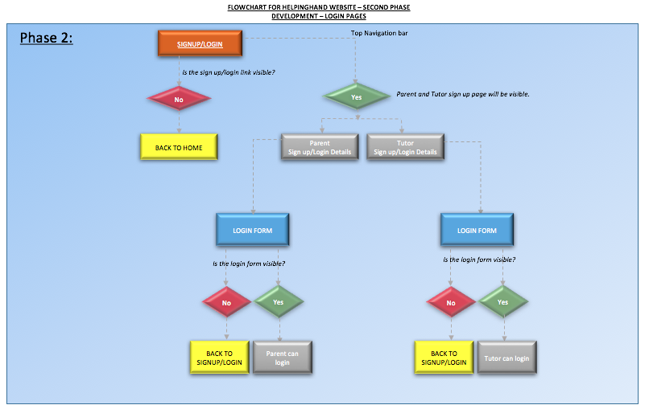

Figure 12: Phase 2 - Backlogs

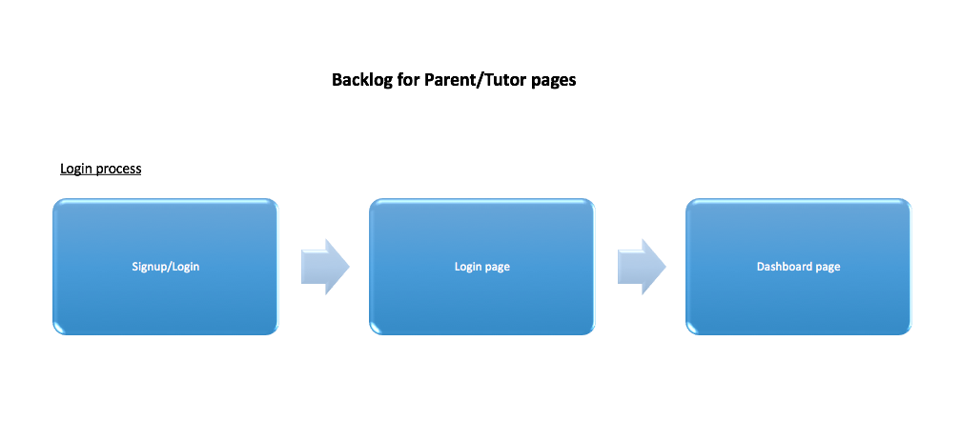

Figure 13: Backlog for Parent/Tutor pages

## Organisation of team:

The team was organised in the following way:

* Front-end development
* Back-end development
* Database management.

## Sprint planning meeting:

A ‘sprint’ meeting was organised to plan how to effectively manage the agile development process. Within the meeting it was decided how the structure of the sprints and backlogs would be set and detailed that each team member would be responsible for carrying out the task that had been assigned to them and reporting back to the team if their progress or if they required any assistance in order for them to complete their sprint.

## Frequency of sprints

For logistical reasons the frequency of sprints was set to twice a week.

## Scrum meetings

Scrum meetings were organised every two days so that sprints could be set. The scrum meetings were held for no longer than 15 minutes. Within the scrum meetings it was also taken as an opportunity for team members to feed back to the rest of the team what they had completed since the last scrum meeting and any issues that arose.

## Technology used to organise Kanban

In order to implement and keep track of Kanban’s the development team used gitlab. The development team decided to use gitlab as this environment was being used to upload code. It allowed to keep an accurate track of sprint progress and closure.

## Creation of Backlog

Once the sprints had been set a backlog was then created (see Figure 14 below). The creation of the backlogs was the most efficient and practical way to set tasks for the development team, as each sprint was delivered by way of notification to the relevant member of the development team. This also allowed the “Scrum Master” to keep track of what sprints were outstanding (see Figure 15 below) and the sprints that were in progress (see Figure 16 below).

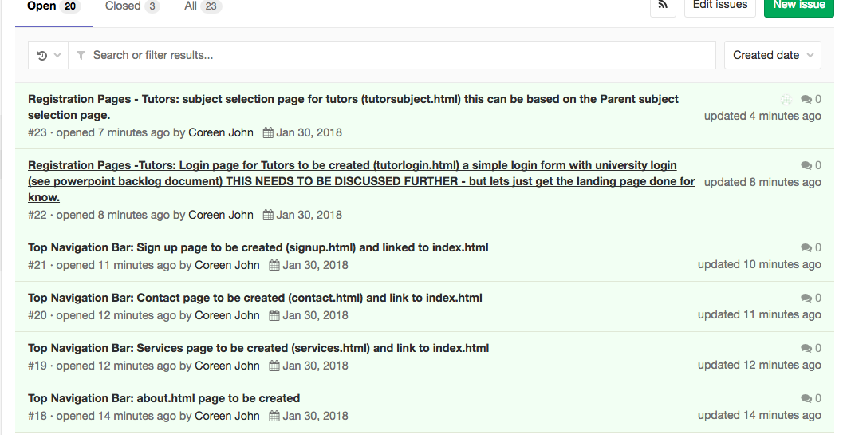

Figure 14: New sprints

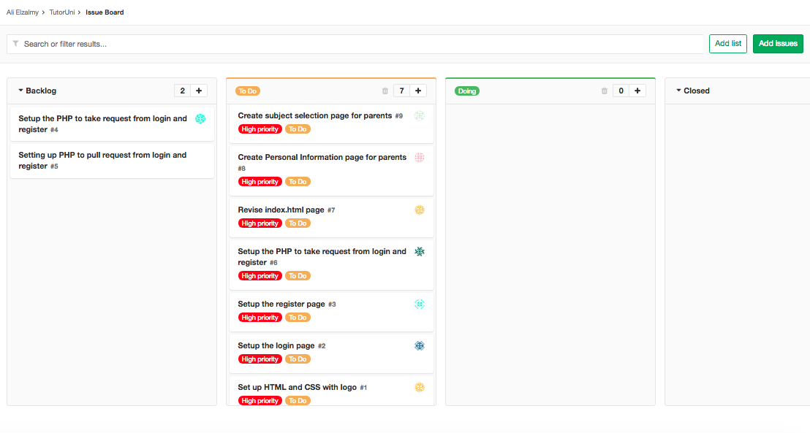

Figure 15: Sprints - To do

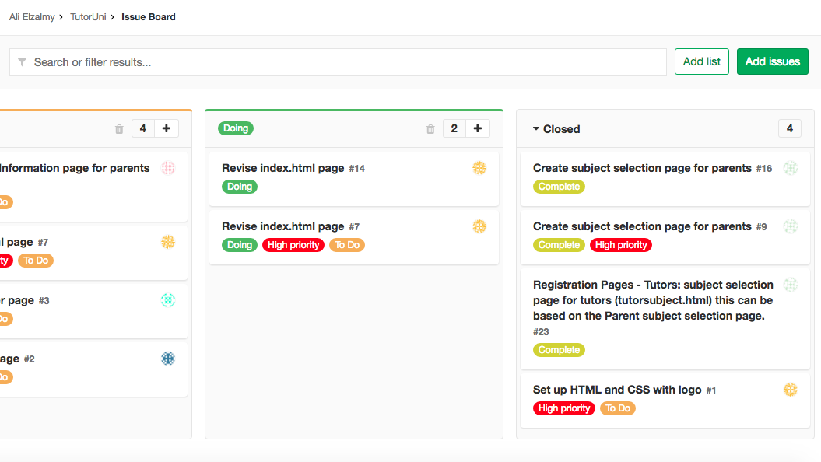

Figure 16: Sprints in progress

## Complete

Once the team member had completed their sprint, the item was then moved to the complete board (see Figure 17 below).

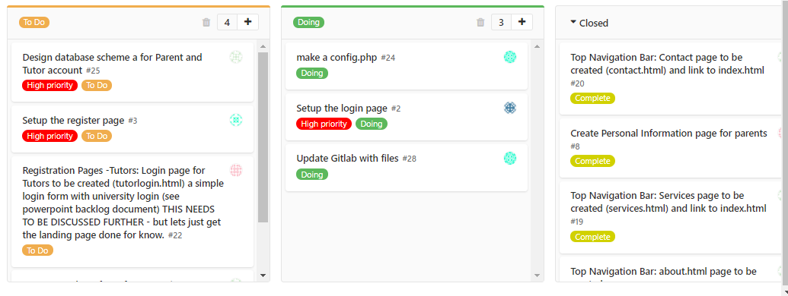

Figure 17: Closed sprints

## MVP

Once the workflow, backlogs and sprints were finalised a minimum viable product (MVP) was created. The creation of the MVP was key to moving onto the next cycle of the application development, user testing (which is detailed in 3.1 below)

# Formative Evaluation

As part of the development process we undertook a detailed process of evaluation with our users. We chose to conduct our user testing using a group of six participants. We used version two of our application as this was the second phase of our MVP, we wanted to test that the participants were able to navigate around the system and undertake a process of logging in (which would be the main focal point of using the application). The following section explains in full detail the approach that was taken.

## User testing

A test plan was devised that aimed to carry out the activities of specific tasks and questions which gave our users clear guidance on what actions to take and what features to speak about, when using the Helping Hand web application. The evaluation was conducted in the form of a recorded observation. From the study, the aim of the research was to focus on the specific issues that we were interested in investigating. In order to identify what specific issues we aimed to solved the following questions were asked:

* + Do our users understand how the product works and do they find it effective?
  + Can our users easily navigate through the web application without any difficulties?
  + Is the overall content on each page delivered and laid out appropriately?

## Testing Constraints

We also ascertained that there would be constraints that would impact the testing process. The limitations that were identified that could affect the user testing process was as follows:

* + Non-functional product;
  + Lack of equipment;
  + Equipment issues;
  + Testing location not prepared; and
  + Consent agreement not signed by participants.

## Testing parameters

The usability study examined and gathered assessment data with the aim of measuring the effectiveness of the Helping Hand web application. A minimal viable product was introduced to our users for which they were asked to test its main features and judge the overall functionality.

We also required our participants to make an attempt to login to a HelpingHand accounts which would then redirect the user to a dashboard page. By connecting to the dashboard page would test whether or not the user was able to connect to the HelpingHand database. For the purposes of the testing we provided our users with predetermined user logins.

## Schedule and testing location

We used a controlled setting to conduct the testing sessions. The study took place in Room 204 within Goldsmiths University. The session was conducted on 5 March 2018.

## Participant recruitment/approach

Based on the profile of our uses (identified by our user stories) we recruited students who would be potential tutors for our application. In order to test the effectiveness of the application we did not recruit participants with a desire to become a tutor. We decided to take this approach as we need to establish whether the application was informative and displayed the correct type of information.

## Facilitator and observer details for each session

In order to ensure the that the testing was as seamless as possible we divided the team as follows:

* Facilitator;
* Observer
* Recorder of audio and screen
* Recruiters

The role of the facilitator within the session was to help participants understand the common objectives and assists them on how to plan how and achieve the set objectives. The facilitator remained "neutral" ensuring that they did not take any particular position within the study. The facilitator started the session by introducing the session and project as a whole and then introducing the tasks that were to be carried out. The facilitator remained in the same room as the participant whilst the study was being conducted.

## Session details

The testing session was set-up in the following way:

* + The team met an hour before the allotted testing time to set up the room and ensure that the equipment was in good working order by carrying out a test session.
  + Participants were welcomed on arrival and was allowed some time to prepare for the session.
  + Once the participant was ready, they were given a debrief on the session and the importance of their involvement in the study, the role of the facilitator, equipment used, protocol for the rest of the session was explained. The script below shows the script that was used for the testing session.

**System Usability Testing Script**

| **Step** | **Instructions** |
| --- | --- |
| 1 | |  | | --- | | Please ensure the testers web browser is showing a neutral e.g. a search engine | |
| 2 | ***Introduction:*** |
|  | Hi [*testers name*]. My name is [*your name*] and I will be walking you through today’s session. |
|  | Before we start the testing session I would like to go over some information and I shall be reading the information to ensure that everything is covered. |
|  | I have already briefly explained why I have invited you here today but I just wanted to go over it. We are asking people to try and use our website that we are developing to see if it works as we intend it to. The session should take no more than [*insert time – TBC*] |
|  | I just want to confirm that we are testing the capabilities of the website, at no time are we testing you. There is no wrong or right answer, and please do not worry about making mistakes. |
|  | As you go through using the site it would be very helpful for us if you could think out loud (please be assured there is no pressure on you to carry this out), *but* it would be really helpful for us if you can. So for example try and express what you are looking at or what you are trying to do. |
|  | We would really value your honest opinions and reactions to the use of our site. Your honesty will help us to make necessary improvements to our site. |
|  | If you have any questions as you are going through the use of the site, please ask. We may not be able to answer your questions immediately as we are really interested in observing how you use the site when we are not there to help you. But if you do have any questions on completion we will try to answer them. |
|  | If you need to take a break at any time, please feel free to do so. Also if at any time you wish to stop testing you are also free to do this as well. |
| 3 | ***Recording*** |
|  | In order to efficiently observe your usage of the site, we would like to record you using the site. With your permission, we will record your hand, screen and voice (if you are comfortable with talking out loud). Please be assured that the recordings will only be seen by myself and the rest of the development team. The recordings will help me as I will not have to take as many notes and can therefore properly observe how you are using the site. |
| 4 | ***Consent form:*** |
|  | I have a simple consent form which I will ask you to read and sign. The consent form confirms that we have your permission to record you and the recording will only be seen by the development team. |
|  | |  | | --- | | Please give the tester a consent form and pen  Whilst the form is being signed, START RECORDING. | |
|  |  |
| 5 | ***Background questions:*** |
|  | Ask the user if they have any questions so far. |
|  | Before we start looking at the site, I would like to ask you a few short questions. |
| (a) | Firstly, what is your occupation? What are the main activities you do all day? |
| (b) | Could you give a rough estimate of how many hours you spend per week using the internet (including browsing the web, accessing and sending personal/work emails). |
| (c) | What is the split between using email and browsing (a rough estimate will be fine) |
| (d) | What kind of sites do you look at when you are browsing? |
| (e) | What are your favorite websites? |
|  | OK that’s the end of the questions now we can start looking around the website: |
| 6 | ***Website testing:*** |
|  |  |
|  | |  | | --- | | Click on the bookmark for the site’s Homepage. | |
|  |  |
|  | Firstly, could you look at this page and tell me what you thing about: what is the most striking thing about it? Can you tell what you are supposed to do with the website, who is the website for? Just have a look around and do a little narrative. |
|  | You are free to scroll but please don’t click on anything as yet. |
|  | |  | | --- | | Allow the test to do this for nor more than 3-4 minutes max. | |
|  |  |
|  | Thank you. I am now going to ask you to try and do some specific tasks which are based around the website. I will give you a printed copy and I will also read each task out aloud. |
|  |  |
|  | |  | | --- | | Please give the tester the first scenario and read it out.  Allow the tester to continue until you feel that it is not producing any value to the analysis or if the user is becoming frustrated with the process  Allow the tester to repeat this process for each task or until the testing time runs out. | |
|  |  |
| 7 | ***Final Questions and user feedback:*** |
|  | The testing is now complete do you have any questions or general feedback? |
|  |  |
|  | |  | | --- | | Stop the screen recording or mobile recording and save the file.  Thank the tester and escort them out. | |

**Scenarios**

**Scenario 1:**

| **Step** | **Instructions** |
| --- | --- |
|  | Task: Registering on HelpingHand Website. |
|  | Say you have a 10 year old child who you feel could benefit from some extra tuition as you are unable to help them due to language barriers (English is not your first language). You would like to find a quick, informal and reasonably priced way of finding a good tutor online to help with school subjects and homework. You would like the tutor to have the ability to preferably speak your mother tongue and be able to tutor your child at home. |
| 1 | Step 1: Go to the registration page to register as a new user on the website. |
| 2 | Step 2: Enter your personal details and the subject preferences for you child. |
| 3 | Step 3: Look on your personalised dashboard page to ensure all of your preferences have been recorded correctly. |

**Scenario 2:**

| **Step** | **Instructions** |
| --- | --- |
|  | Task: Using and logging on to the HelpingHand Website. |
|  | You are a university student and you could really benefit from some part time work to earn extra money. You have registered on a brand new website called HelpingHand to work as a tutor in your spare time, offering tutoring services to children whose parents feel could benefit from some extra tuition. You are able to offer your tutoring services for approximately two hours a week. |
| 1 | Step 1: Go to the login tab and login into the system. |
| 2 | Step 2: Enter your username and password (this will be provided) |
| 3 | Step 3: You should see a dashboard page. |

* + The participant was asked to review and sign the consent form (see Appendix A below..
  + Once confirmation had been given that the participant understood what the session would entail the testing of the HelpingHand application began.
  + The participants where asked general questions to start (to try and gain understanding of what they did day to day and how they interacted with technology). The participants were then given a specific set of tasks to carry out (for the purposes of the testing we asked participants to follow Scenario 2 which is described above). We asked the participant to take a look around the general pages of the application so that we could analyse and determine whether they knew what the purpose of the application was. We then asked them to login to the system (For the purposes of the testing we provided each participant with a username and login – see Figure 18: Dummy logins below). We wanted to analyse how easy the process was and how long it took each participants to navigate around the system (so to measure how easy it was to enter their details within the given fields. Once the task of logging in was complete we asked the participants to give us any feedback or further suggestions.

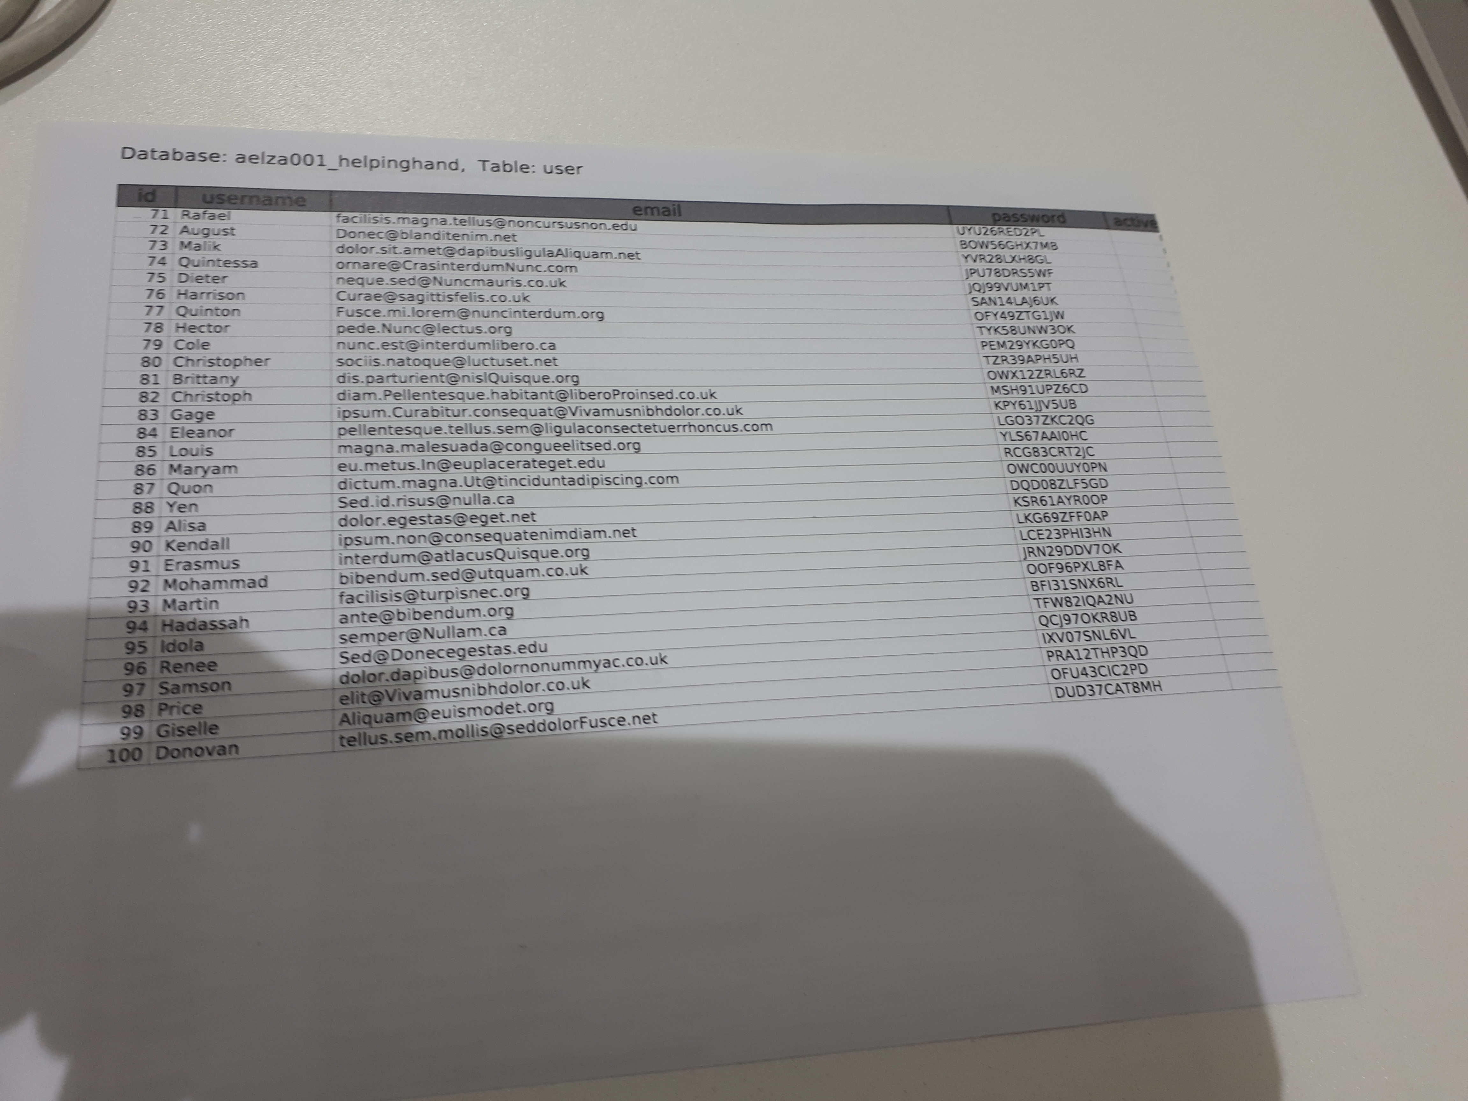

Figure 18: Dummy logins

## Session recording

The session was recorded in the following ways:

* Recorded video: the session was digitally recorded on video and audio using a smartphone. The video recording captured the participants hands from an overhead shot camera angle whilst conducting the session, this approach was used to maintain confidentiality.
* Screencast: as well as recording participants digitally, a screencast recording was also used so that a deeper analysis and understanding could be made.

## Outcome of user testing

In order to analyse and gain feedback from the user testing sessions we collated and analysed all recordings from each session and produced the following qualitative and quantitative data about participants’ experiences using the web application. Table 1 to Table 6 below outlines what each user did throughout the controlled tested. Table 7 below outlines what the participants observed and there is also a link to each user’s screencast which can be viewed for further insight into how our participants carried out the user testing.

**Testing Analysis sheet**

| Step | Feedback | Action |
| --- | --- | --- |
| *User 1* | | |
| What is your main occupation? | Student | N/A |
| What are your main day to day activities? | User is a journalist who predominantly studies articles and runs his own website. | N/A |
| How many hours spent each week using the internet? | 10 hours | N/A |
| What do you mostly do on the internet? | Networks online | N/A |
| What kind of sites do you look at when browsing? | Articles | N/A |
| What is the most striking thing about the page you are looking at? | User notices a strong background image which sets outlook on what the website is about which is further complemented by the strong bold heading typography. | No action needed. |
| Can you tell what you are supposed to do with the website? Who is the website for? | User states the website’s layout and design sets out a brief intention of what the website is about. At a glance, the user doesn’t know who the website is aimed for however he has stated with further investigation he would likely comprehend who is aimed for. | More information on the homepage. |
| Step 1: Go to the login tab and login to the system. | User knows where the login button is located with no difficulty | No action needed. |
| Step 2: Enter your username and password (this was provided to the user) | It has taken the user 0.7 seconds to enter dummy data we have given him. | No action needed. |
| Step 3: Visible dashboard page should be displayed | User was able to login successfully | No |
| Questions and feedback | The user comments that if you were to stumble upon website on the search engine, one might assume it is an online self-taught tool rather than tutoring service. | Add a better description or maybe more information entailing the websites true representation. |

Table 1: User 1 - Testing analysis

| Step | Feedback | Action |
| --- | --- | --- |
| *User 2* | | |
| What is your main occupation? | Student | N/A |
| What are your main day to day activities? | Studying | N/A |
| How many hours spent each week using the internet? | 3 hours but believes it might be more | N/A |
| What do you mostly do on the internet? | Watching the news, social networking, browsing through images. | N/A |
| What kind of sites do you look at when browsing? | Social Media sites like Facebook and YouTube. | N/A |
| What is the most striking thing about the page you are looking at? | Clear title in the middle and the transparent background. | N/A |
| Can you tell what you are supposed to do with the website? Who is the website for? | User has difficulty knowing what the website is about and who is aimed for because of the limited information displayed on the home page. | More information is needed. |
| Step 1: Go to the login tab and login to the system | No problem finding where the login button was located. | No action needed. |
| Step 2: Enter your username and password (this was provided to the user) | It has taken the user 0.6 seconds to enter the login data. | No action needed. |
| Step 3: Visible dashboard page should be displayed | Dashboard is displayed | No action needed. |
| Questions and feedback | The user states the website is simple. | No action needed. |

Table 2: User 2 - Testing analysis

| Step | Feedback | Action |
| --- | --- | --- |
| *User 3* | | |
| What is your main occupation? | Student | N/A |
| What are your main day to day activities? | Studying, reading and watching films. |  |
| How many hours spent each week using the internet? | Approximately 35 hours per week | N/A |
| What do you mostly do on the internet? | Emails, social media, online bibliography etc.. |  |
| What kind of sites do you look at when browsing? | Social Media sites | N/A |
| What is the most striking thing about the page you are looking at? | The white font stands out a lot with a clear large background. | N/A |
| Can you tell what you are supposed to do with the website? Who is the website for? | User comments the description in the middle of the website helps him know that it is a website which aids students struggling with learning. User comments that they see the buttons at the top however he doesn’t know where to go from next. | Perhaps a step by step function is needed to guide new users where to go. |
| Step 1: Go to the login tab and login to the system. | User has no difficulty locating the login button and where to login. | No action needed |
| Step 2: Enter your username and password (this was provided to the user) | It has taken the user 0.9 seconds to enter the dummy data. | No action needed. |
| Step 3: Visible dashboard page should be displayed | Dashboard is displayed | No action needed |
| Questions and feedback | User states the dashboard has too much white space and can add more content to make it more professional. | More content on the dashboard. |

Table 3: User 3 - Testing analysis

| Step | Feedback | Action |
| --- | --- | --- |
| *User 4* | | |
| What is your main occupation? | Student | N/A |
| What are your main day to day activities? | Going lectures | N/A |
| How many hours spent each week using the internet? | 20 hours | N/A |
| What do you mostly do on the internet? | University portal website for readings and lectures. | N/A |
| What kind of sites do you look at when browsing? | YouTube and browsing sites for inspiration. | N/A |
| What is the most striking thing about the page you are looking at? | Main heading is large and clear which stands out the most | N/A |
| Can you tell what you are supposed to do with the website? Who is the website for? | Children struggling with learning | No action needed |
| Step 1: Go to the login tab and login to the system | User knows where to login. | No action needed |
| Step 2: Enter your username and password (this was provided to the user) | It has taken user 0.11 seconds to login | No action needed |
| Step 3: Visible dashboard page should be displayed | Dashboard is displayed successfully. | No action needed |
| Questions and feedback | User states that after logging in, a transition like effect should pop up to let the user know they have logged in successfully rather than dashboard showing up. | Letting the users know that they have logged in successfully. |

Table 4: User 4 - Testing Analysis

| Step | Feedback | Action |
| --- | --- | --- |
| *User 5* | | |
| What is your main occupation? | Student | N/A |
| What are your main day to day activities? | Reading | N/A |
| How many hours spent each week using the internet? | User does not know | N/A |
| What do you mostly do on the internet? | Social Media | N/A |
| What kind of sites do you look at when browsing? | Social media sites like Instagram. | N/A |
| What is the most striking thing about the page you are looking at? | Simple and direct heading. User believes the heading is too simple. | Add more variation to home page. |
| Can you tell what you are supposed to do with the website? Who is the website for? | User says the website is a tutoring app who might be for students, teachers and parents. | No action needed |
| Step 1: Go to the login tab and login to the system | No problem finding the login button | No action needed |
| Step 2: Enter your username and password (this was provided to the user) | It has taken user 0.10 seconds to login | No action needed |
| Step 3: Visible dashboard page should be displayed | Dashboard is displayed after logging in successfully. | No action needed |
| Questions and feedback | No comment | No action needed |

Table 5: User 5 - Testing analysis

| Step | Feedback | | Action |
| --- | --- | --- | --- |
| *User 6* | | | |
| What is your main occupation? | Teacher | N/A | |
| What are your main day to day activities? | Studying and teaching. | N/A | |
| How many hours spent each week using the internet? | 8 to 9 hours per week | N/A | |
| What do you mostly do on the internet? | Watching films, shopping, emails and research materials. | N/A | |
| What kind of sites do you look at when browsing? | Emails, research materials | N/A | |
| What is the most striking thing about the page you are looking at? | Large and clear heading | No action needed | |
| Can you tell what you are supposed to do with the website? Who is the website for? | Tutoring website to assist children with learning. | No action needed | |
| Step 1: Go to the login tab and login to the system. | User knows where the login button is located with no difficulty | No action needed | |
| Step 2: Enter your username and password (this was provided to the user) | It has taken the user 0.12 seconds to login | No action needed | |
| Step 3: Visible dashboard page should be displayed. | Dashboard is displayed successfully after logging in. | No action needed | |
| Questions and feedback. | User likes the websites | No action needed | |

Table 6: User 6 - Testing Analysis

|  | Observational Comments | User screencast |
| --- | --- | --- |
| User 1 | User 1 really liked the simple and clean layout the website displayed, however had difficulty differentiating if the website was a self-learning tool rather than an actual tutoring service. The user also did not go navigate through the website as much and was rather quick to make a statement on the website. | [User 1 screencast](https://www.youtube.com/watch?v=d3Rbn1XGhLc&t=49s) |
| User 2 | User 2 has difficulty knowing what the website is about and who is aimed for because of the limited information displayed on the home page. They scrolled through the website and tried to explore and found it lacking which really affected their perception of our testing. | [User 2 screencast](https://www.youtube.com/watch?v=qLK29VAKyHg&t=1s) |
| User 3 | User 3 had a good suggestion about the after process of logging in. A step by step function was suggested to guide new users where to go after they have signed in successfully. They found the website easy to navigate through and had no problems logging in. | [User 3 screencast](https://www.youtube.com/watch?v=sRQgZX1q9Ns) |
| User 4 | User 4 suggested that a pop-up effect transition could have been used to tell the user they signed in successfully rather than going straight to the dashboard. They also did not find any difficulty logging in and navigating to the login button | [User 4 screencast](https://www.youtube.com/watch?v=8GYFGqS9isQ) |
| User 5 | User 5 didn’t have much to say about the website. They had no difficulty going through the login process and did not struggle to do so. | [User 5 screencast](https://www.youtube.com/watch?v=yvJJiP_zZpk) |
| User 6 | User 6 thought that the large and clean heading was a nice introduction to website. They really enjoyed the colour scheme and fonts. | [User 6 screencast](https://www.youtube.com/watch?v=sPAoiWC0bzo) |

Table 7: User Testing - Observational Comments

## Summary of user testing

Upon gathering feedback from the targeted users, the development team were able to collate and gather lots of useful data from the selected group. Using qualitative usability testing, was the most crucial step of user testing as by observing users the development team where able to understand the users’ judgement by asking a series of questions. The use of a live prototype was essential for the users to help determine what was necessary for the application as considerations could be made as to what might make the experience work better for our targeted group.

A total of six participants was used to collect feedback on the web application prototype. Users were asked a series of question and tasks to carry out for this type of application. The users were documented by recording footage of them of using the application and a screen recording of the screen to observe users with minimal disruption. Crucial questions such as: What is the most striking thing about the page you are looking at? Were important in trying to ascertain the users first impressions of the home page. The feedback from this was positive, with most participants commenting that the heading was the most striking thing, because of the bold typography and white background. Other participant’s feedback stated that the large background image helped give a clear understanding of what the website was being aimed at. However, one participant commented that they had difficulty perceiving what the website is about and who is aimed for because of the limited information displayed on the home page. The participant scrolled through the website and tried to explore and found it lacking which really affected their perception of the testing process. This was further supported by another participant stating they had difficulty differentiating if the website was a self-learning tool rather than an actual tutoring service. This was most significant, because it would change the whole purpose and concept of the application and as a result it could be perceived as being something that it was not. As a result, this led to the development team to make adjustments to the perception of the website.

We further explored the participant’s feedback by giving them a set of tasks to do. One participant suggested that there should be a “pop-up” like transition to greet the user that they had logged in successfully. This was also implied by another user, who proposed a feature mechanism which helps to guide new users where to go after they had signed in successfully into their account. By testing participants, crucial vulnerabilities in our project were discovered, which ultimately led to making improvements.

# Design and Implementation

## Implementation

When the initial design was implemented there was a certain structure that was going to be followed. Following on from the market research that was previously conducted and collated and the testing that was carried out on the prototypes. The first initial step was to create a homepage and a login system. After conducting the user testing it was decided that certain aspects of the website needed to be changed. For example, the initial idea was to have the homepage as a login/registration. However, after testing and feedback it was established that this structure would not display enough information to the user or anyone wanting to find out about the web application. The decision was taken to implement more information on the homepage and have an about page. This would assist the user in identifying the HelpingHand brand. It was very important to ensure that users would know how to navigate to the login page from the homepage. During the user testing observations were made of user interacting with the website to make sure the usability was of a high standard.

## Design amendments

Another major design that was amended was that in the design stage inspiration was going to be made from the App quick where you would have an extremely simple interface that suggest “Give help” and “Get help” (see Figure 19 below). It was decided to implement the methodology into the login page. The login page will contain two separate logins (one for tutors and one for parents). The login page will refer the user to login without being referred to another page. This also ensures easier navigation for the user. According to Liu et.al (2010) the first 10 seconds after the user enters a website are extremely critical in whether a user will leave the website so that is why the decision was made to go for the much simpler design.

## Key components

One of the key components in the design concept was Shibboleth authentication system would be implemented to verify tutors via their university email address and password. The Shibboleth system is a Privacy Preserving Identity Management system which verifies students from any university to be valid. In the initial design it was a core part of the login system as it would complete verification. This would help build a trust relationship between the parents and the web application. The Shibboleth open source system was unable to be implemented as part of the login systems. When the Goldsmiths University shibboleth system was being implemented it was unsuccessful as, full access to the Goldsmiths database and security system need to be granted. The database manager was not able to assist in the implementation of the access to the database and security system. In order to adapt the system so users could be validated, the system was adapted so that it had a validation email form field by making sure it contained a university email. If the email entered does not contain a university email it would not allow the user to register. By implementing this system, it would allow a verification email to be sent to the tutors’ university mailbox to validate them as a user.

This was a major change in the initial design, and such that this had to be verified by our users to ensure they found the adaption suitable. By conducting user testing with observing and questioning (see 30 above). We had to establish that our initial target market (tutors and parents) were satisfied with the adaption and that it would still be a viable service. as one of the key issues with services that connect unassociated people together security. There needs to be a relationship of trust between the service and the user which has had to be kept in consideration whilst designing and implementing the application.

Quick

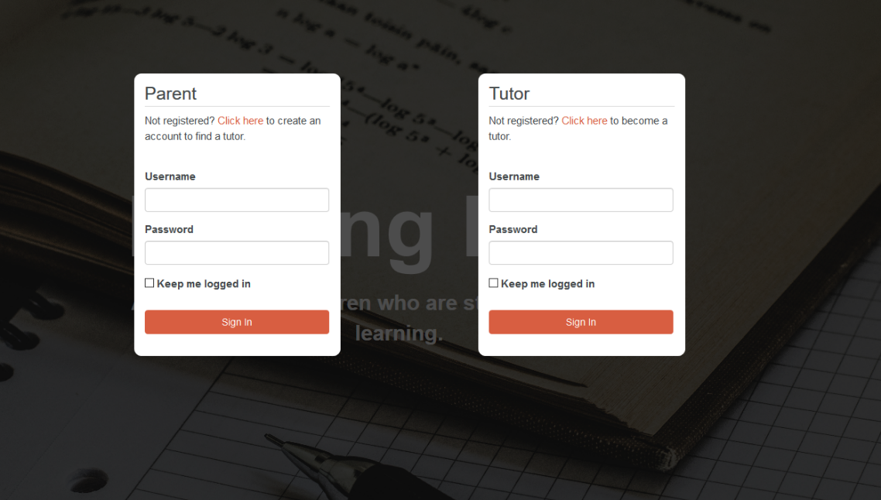

Figure 19: Give Help, Get Help

# Quality Assurance

In order to ensure that the application being developed was of a good quality it was decided that unit testing on the system should be carried out as follows:

## Unit testing

In Figure 10: Phase 1 – Flowchart for Backlog above it was illustrated that our development phase was split into two parts. The first phase was to develop the first few pages of the application:

* Home
* About
* Services
* Contact



Figure 20: Pages to be used for unit testing

## Test cases

In order to test the viability of Phase 1 a number of test cases were set up. The ultimate aim of the test case was for the first four pages of the website to be tested to ensure that they were fully functional. The test cases were set up with a list of instructions and the expected outcomes. The tester would find the instruction on what to test on the test description. Detailed instructions on each step was given for the tester to follow and the table also displayed what the expected outcome should be, please see Figure 22 below for a detailed analysis of the test case that was carried out. The tester was able to make notes after the unit testing had been carried out to confirm whether or not the unit testing had worked. According to what was placed in the pass or fail the relevant column was updated to display whether or not the unit test had passed or failed. Once it was established whether the unit testing had passed or failed we were able to the create more sprints for the development team to undertake further development.

## Carrying out the unit testing

All of the pages were tested to ensure that the pages were all interactive and displaying correctly (see Figure 21 above).

Figure 21: Webpage interaction

The tester went through each test case according the page that was being tested and matched what they could see with the expected outcome. The result would either be a pass or fail and a note was written to explain why the test case had failed. Once the test cases were analysed the development team were able to incorporate any fixes into the application (see Figure 22: Test case results below).





Figure 22: Test case results

# Ethical Audit

In order to ensure that the ethical needs of users of the application the following ethical audit of the HelpingHand application was conducted.

## Privacy Policy

Helping Hand ensures that personal information is used and collected in a way where users have a right to expect that all data is treated with total confidentiality. HelpingHand Privacy Policy is designed to help users understand how their data is collected and how their personal information is used. HelpingHand has aimed to make informed decisions when using the website and any features on them, including registration and user login.

## Collation of personal information

The personal information that is collected may include users name, contact details (phone numbers, email address), home address, date of birth, academic subjects, languages, complimentary subject, support subjects, musical instruments, level of study, mode of study, as well as any other personal information that users may supply.

## How personal information is collected

The only personal information that is collected by HelpingHand is the data users choose to disclose. For example, users may provide their information when they post a job request on their site, when they register to use the services, when they contact HelpingHand (online or offline) or when they have updated information on their accounts.

## What is done with personal information

Users personal information will be used, for example, to provide them with the relevant services, to process their requests online, to improve the services offered by HelpingHand, for market research purposes, to prevent or investigate security breaches or fraud and otherwise to better meet the needs and preferences of the users. HelpingHand will never share any user’s information with third parties without their consent.

## Data protection

Helping Hand will need to process (that is, collect, use, store and ultimately destroy) personal data about users (as a tutor or parent) to be able to record their application for the services, to authenticate user credentials, to gain access into user’s account and to maintain contact with the users. All data records will be stored and managed via the central database system. This will be controlled by the HelpingHand development team. Each member is responsible in ensuring that computer records are password protected and not shared with any other individuals outside of the HelpingHand development team. In the case of users making the decision to have their accounts closed, all their personal data they have provided will be permanently deleted off the database system and no longer retrievable.

## Intellectual property

The HelpingHand name and logo is the property of HelpingHand and may not be copied or distributed without consent. All content published, displayed or performed on the website (including, text, photographs, images, video clips, interactive applications and search features) is protected by intellectual property rights, which are owned and controlled by the HelpingHand team. We do not grant permission for any users in obtaining rights to our content this includes of copying, selling, reselling, rental, lending, adaptation, reproduction, distribution, publication, modification, broadcast or promotional use.

# Summative Evaluation

The general aim of our study, was to design and develop a tutoring application which proposes to help connect parents with university students to provide tuition services in the subject that the child needs assistance with. This project was deployed to help the inequalities of education for less affluent students to benefit from private tuition.

The design process involved extensive market research through our target group to help identify the most appropriate platform and features which would meet the needs of the end user. We also took inspiration from the likes of Tinder, Amazon Prime & Quick to add creativity and a distinctive edge to our overall concept. In order to test the viability of the design we used a three-step process to test our model – conceptual, functional & technical (minimum viable product) prototyping. Our model was presented using wireframe, PowerPoint presentation & JQuery application – all in which, feedback was collected through a survey after users had engaged with the design.

Within our research, we learnt that 67% of the users were quite satisfied with the functional prototype in which they felt the interaction and design of the product ‘suited the concept well’. The feedback also gave insight on the users understanding and realization of the initiative behind having University students as tutors for the project. For the remaining 33% of the targeted groups who tested the MVP were not as confident about the practicality of the platform. The early adopters felt ‘confused’ when using the product as they could not quite understand the steps on how the ‘overall service worked’. The target group recommended that an inclusion of a ‘short guide at the beginning of the application’ or even on ‘every single page’ which would help users better understand the process and to fully utilise all the platform’s features.

From these findings, we were able to establish how the interface could be redesigned and further developed to ensure that the needs of the users are met. Our adaptation of the final application would concentrate on including sufficient features with a UX-friendly design. Our objectives for developing the platform was to build an innovative web application with a simple, yet engaging user interface and experience.

We approached our development phase of the project in way where we deployed a minimalist design with only necessary elements for functionality included in the platform. This was intended to manage the application into phases which would provide a simple and consistent frame of reference for everyone involved in the project. The development was handled by dividing the project team into two groups which would focus on each of our two end users - parents and tutor. Each group worked on the user interface that would essentially form the HelpingHand application. We used GitLab as our central repository for the management of sprints and backlogs for each group to effectively develop and complete assigned tasks. We felt the use of this environment significantly helped create and manage milestones across the project efficiently, in that we were all able to mutually work as a unit when accomplishing our objectives. Both groups were able to successfully engineer the main structure of the website around HTML, CSS and PHP. These programming components equally made up the front-end and back-end of the application. The first phase was handled across the whole team to build five webpages which would be seen as the main entry point into the application. Each webpage would also serve as navigation links for our users when using the platform. The team demonstrated its effectiveness in achieving this task without any real constraints. Phase two focused on the design and handling of user’s registration and login. Each group would approach the same principles when developing the registration and login page in ensuring the same functionalities were provided for both users. This was primarily agreed to maintain a coherent interface design throughout our application. We further emphasised this approach in our backlog along with the set tasks for this phase. Despite each group completing their assigned implementations, the team faced major obstacles and challenges throughout this phase which heavily impacted the project’s overall progress. The main area that caused each group member the most problems would be when attempting to handle PHP with the application in delivering the requested data to the MySQL server. We found a lack of response from the MySQL database when trying to store user sessions on the website and when also attempting to query usernames and passwords. The team collectively worked together for a number of weeks on this obstacle, by generating new ideas and exploiting debugging methods to accomplish the tasks in the end.

Upon completion of the second phase of our application development, we felt it was essential to carry out user testing on our platform during early development stages to ensure we were on track in meeting the needs and preferences of our users. This process carried out activities of specific tasks and questions which gave our users clear guidance on what actions to take and what features to speak about, when using the Helping Hand web application. A minimal viable product was introduced to our users for which they were asked to test its main features and judge the overall functionality. The general objective for the user study was to discover the limitations of our design and validity of the platform through our user’s feedback in order to provide the ultimate user experience. We were able to gather feedback from participates who partook in our observations through video recordings and screencasts. From these findings, we learnt that few of our participants misunderstood our project purpose and concept as they perceived to think our application was a self-learning tool rather than an actual tutoring service due to the lack of content provided within the website. As a result, the development team were able to make the necessary amendments with the issue raised. Through the outcomes of the user testing and further development, we intended on iterating advanced versions of the platform through more user testing but came short due to time constraints.

Overall, although the project may have not achieved its anticipated end goals as outlined in the project proposal, the work delivered by the team to date demonstrated their initiative and willingness to work through tough challenges and deadlines. Our limitations within this project were a combination of both manpower shortages and time constraints which as a result, saw the team only progress up until phase two (version 1.2 of the software). Moreover, although the team may have found the aspect of development more challenging than others, we were all able to utilise on resources we found through research, such as tutorials, examples and guides.

(Word count: 9724)

# Bibliography

All PHP Tricks. (2018). *Simple User Registration Login Script in PHP and MySQli* [Online]. Available at:<https://www.allphptricks.com/simple-user-registration-login-script-in-php-and-mysqli/> [Accessed 2 February 2018]

Alvia (2017) *How much do Uber drives make in 2017?* [Online]. Available at: <http://www.alvia.com/how-much-do-uber-drivers-make/> [Accessed: 21 October 2017].

Chao Liu, Ryen W. White, and Susan Dumais. 2010. *Understanding web browsing behaviors through Weibull analysis of dwell time*. In Proceedings of the 33rd international ACM SIGIR conference on Research and development in information retrieval (SIGIR '10) [Accessed 13th March 2018].

Envatotuts+ (2018) *Webdesign* [Online]. Available at: <https://webdesign.tutsplus.com/tutorials/how-to-write-good-task-scenarios->for-user-testing--cms-29496 [Accessed 26 February 2018].

Krug, S (2010). *Usability Test Script* [Online]. Available at: <https://www.sensible.com/downloads/test-script.pdf> [Accessed 26 February 2018].

Magic Web Solutions (2018). *The Benefits of web-based applications* [Online]. Available at: <https://www.magicwebsolutions.co.uk/blog/the-benefits-of-web-based-applications.htm> [Accessed 10 March 2018].

Strong QA Limited. (2018). *Test Case* [Online]. Available at: <https://strongqa.com/qa-portal/testing-docs-templates/test-case> [Accessed: 1 February 2018].

Usability.gov. (2018) *Scenarios.* [Online]. Available at: <https://www.usability.gov/how-to-and-tools/methods/scenarios.html> [Accessed 26 February 2018].

# Appendices

#### Consent forms from User Testing sessions

As part of the user testing process we asked each participant to sign consent forms to ensure that they understood the process they where been asked to undertake and to ensure that they understood that the recordings and any data gathered would only be seen by the HelpingHand development team.

